 San Francisco Bay University
EE461 Digital Design and HDL

Week#3 Combinational Logic

IV. Exercises
- Are there something wrong in the following codes? And fix them.

1. always@(A or B) begin
if(A) C = B ^ A;
else C = D & E;
F = C | A;
End

Answer:
D and E are defined in the code and error will show if we run above code;
The correct one is:

wire C, D, E;

always@(A or B) begin
if(A) C = B ^ A;
else C = D & E;
F = C | A;
end

2. always@(B)
C = |B;
always@(E)
C = ^E;

Answer:
Same signal(C) cannot be assigned in two different always blocks with two different values. It will show errors.
The updated code will be:

wire C;

always@(B)
C = |B;

always@(E)
D = ^E;

3. always@(posedge clock)
if(A) Q <= D;

always@(Q or E)
case (Q)
0: F = E;
default: F = 1;
endcase
clock : 00001111
D : xxxxxxxx
E : 11110000
Q :
F :

Answer:
The value of F is assigned based on the value of Depending on the Q’s value, the value of F is assigned according to the case statement. If Q is 0, then F is equal to E, otherwise F is equal to 1.

Based on the given waveform values and the value of F will change whenever either Q or E changes, so its waveform and other values will be looking like:

always@(posedge clock)
if(A) Q <= D;
always@(Q or E)
case (Q)
0: F = E;
default: F = 1;
endcase
clock : 00001111
D : xxxxxxxx
E : 11110000
Q : xxxx0000
F : 11110000

4. module top;
wire B;
bar u1 (A,B);
bar u2 (C,B);
endmodule
module bar (input D; output wire E);
assign E=~D;
endmodule

Answers:
In the module, A and C are not defined. The correction is in below:
module top;
wire A, B, C;
bar u1 (A,B);
bar u2 (C,B);
endmodule
module bar (input D; output wire E);
assign E=~D;
endmodule

5. module foo(input A,B; output reg E);
wire C,D;
always@(posedge clock) E=B&D;
assign C=A^D;
assign D=C|B;
endmodule

Answer: In the above program, C and D are not declared accurately. We have to declare as reg or wire but values are assigned inside the module and will show error during compilation.
The corrected code is here:
module foo(input A,B, clock; output reg E);
wire C;
reg D;
always@(posedge clock) E=B&D;
assign C=A^D;
assign D=C|B;
endmodule

- According to the modules IfMux8 and CaseMux8, draw the corresponding circuits and compare them.

Circuit diagram:

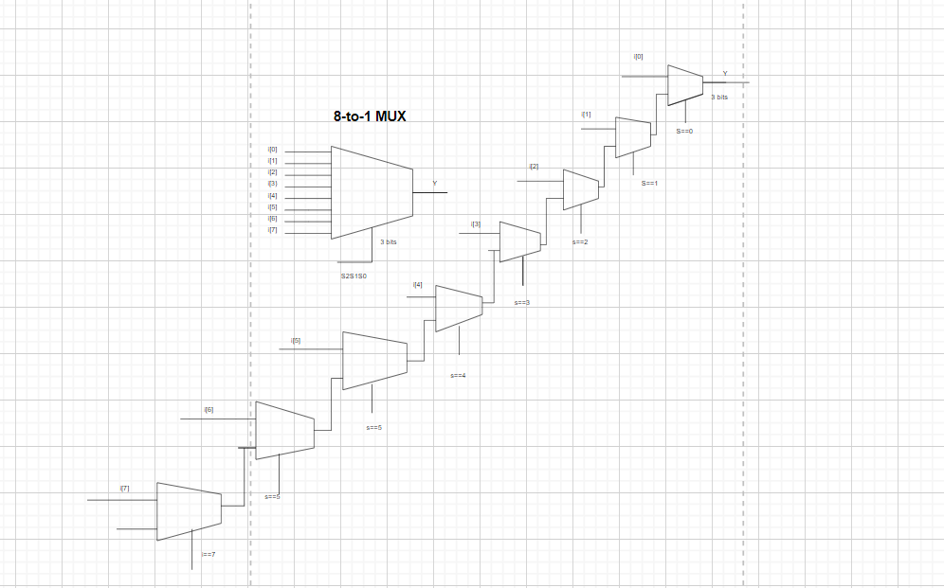

Comparison: The CaseMux8 has a greater number of input options compared to the IfMux8, but requires a larger control signal while IfMux8 has fewer input options but requires a smaller control signal. The appropriate multiplexer to use depends on the specific needs of the application.

